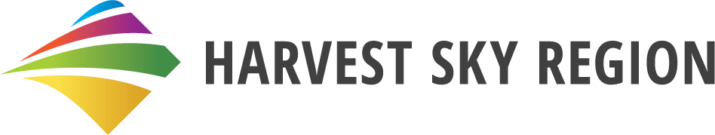**Brand Story**

A prairie lifestyle that lets you slow down and breathe. Wide-open spaces where you can inhale the scent of freshly cut hay, dotted with beautiful lakes surrounded by towering poplars. Here, the vast sky signals endless possibilities in a place where you reap your unique harvest while living a life you love.

Welcome to the Harvest Sky Region, where the simplicity of a prairie lifestyle combines with easy access to local urban conveniences and strong connectivity to nearby communities. With ample land and affordable living, there are limitless opportunities to transform your dreams into reality, while still leaving plenty of time to relax with friends and family or explore the great outdoors.

This is a community waiting for people excited to build a family or retirement lifestyle filled with camping, fishing, or hiking. Your neighbours are warm and welcoming, the kind of people who know your name and look out for each other. While offering excellent healthcare, education, and recreational amenities, the Harvest Sky Region has everything urban life delivers – but with the freedom you only experience when all you hear is the wheat field rustling in the breeze.

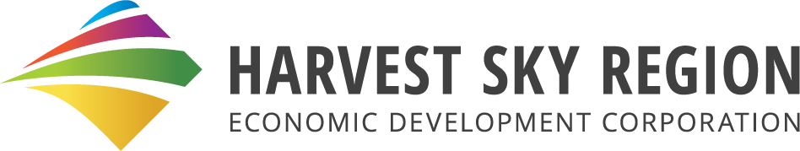

**Strategic Plan – 2025**

**Our Purpose**

Creating endless possibilities in the Harvest Sky Region.

**Our Vision**

We will be the destination of choice for investors, visitors and residents.

**Our Values**

Commitment – we value and rely on dedication from ourselves for the success of our region.

Authentic – we value openness, honesty and integrity in ourselves, our relationships and our work.

Passionate – we value determination and conviction in our people and the work we do for the communities we live in.

Leaders – we support, trust and respect people in our communities and have high expectations of everything we do.

**Our Priorities and Objectives**

Economic Development – We will work to support existing business and attract new investors, visitors and residents.

Economic Development Readiness – We will be at the forefront of regional development information.

Community Development – We will facilitate community development to support economic growth.

**Projects**

**Objective: Economic Development**

Investment Attraction

* Lead generation: we target specific industries, companies & opportunities in a number of categories such as agriculture and energy production.
* Site Selectors: we respond to site selection requests as they come from Provincial and Federal sources.
* Special Areas Industrial Park: we provide project support in an effort to attract tenants for the industrial park.
* Exhibition 31: we are providing assistance to the board of the proposed agricultural centre including marketing and site location & preparation.
* Education Centre: we will work on a proposed educational centre with other, regional stakeholders to drive development using education as a focus to attract people to the region.
* Alberta Advantage Immigration Program – Rural Stream: we provide support to local businesses as they attract workers to move to the region and fill job vacancies.

Visitor Attraction

* Tourism Initiatives & Itinerary Production: we are working on various tourism projects such as a Nickelback Tour and support other tourism operators such as the Hanna Roundhouse, the Back in Time Museum in Youngstown and the Special Areas parks.
* Regional Tourism Partnerships: we work with other, regional tourism stakeholders such as Travel Special Areas, Travel Drumheller & Travel Alberta (Badlands Tourism Zone) to boost regional visitation.
* Hanna Visitor Information Centre: we provide yearly VIC management.

Resident Attraction

* Housing: we are collaborating with other regional organizations to fill needs & attract housing development.

**Objective: Economic Development Readiness**

We provide up to date information for prospective investment and site selectors through a variety of channels.

**Objective: Community Development**

Town of Hanna

• Supporting local projects that strengthen the community and attract visitors.

• Assisting with facility improvements and exploring opportunities for new development.

• Working on recreation and tourism initiatives to enhance local experiences.

Village of Youngstown

* Community Revitalization: we provide support to the Village to address areas such as downtown revitalization and upgrades to parks and campgrounds.